Spark VM Setup

Deployment Platform:

i. Platform Requirements
- Operating System: You can use Ubuntu 14.04 or later (other Linux flavors can also be used like CentOS, Red hat, etc.)
- Spark: Apache Spark 1.6.1 or later

ii. Setup Platform
If you are using Windows / Mac OS you can create a virtual machine and install Ubuntu using VMWare Player, alternatively, you can create a virtual machine and install Ubuntu using Oracle Virtual Box.

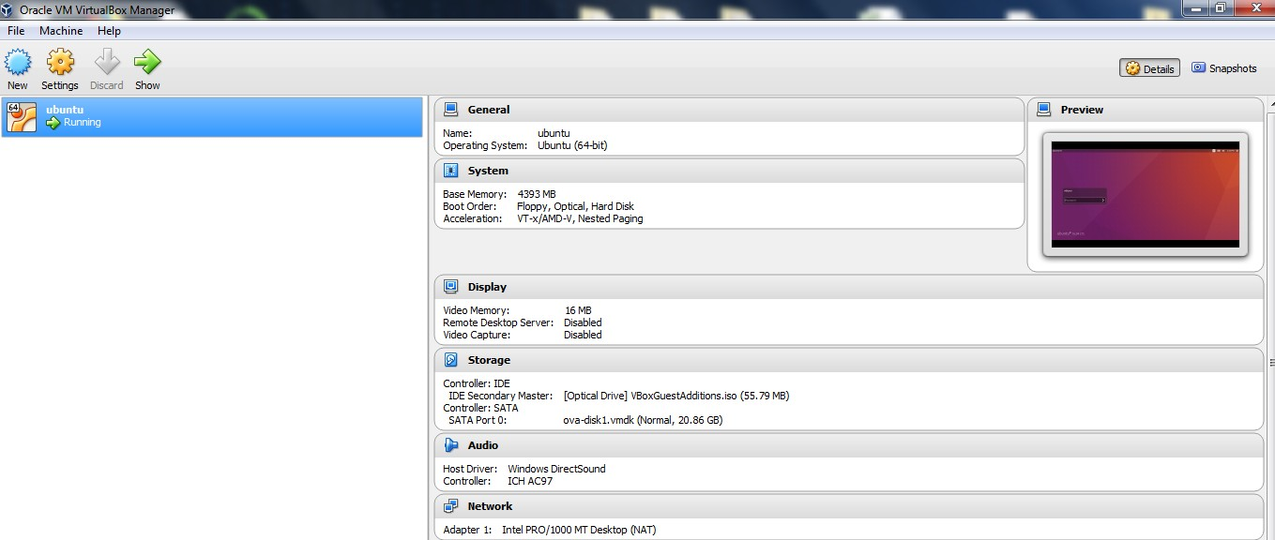

iii. OS Platform

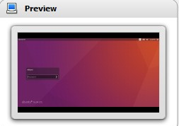

Spark installation on Ubuntu:

Step 1:

Before installing Spark, you need to First ensure that java8 is installed:

1  2  3 | sudo add-apt-repository ppa:webupd8team/java  sudo apt-get update  sudo apt-get install oracle-java8-installer

Verify that java is correctly installed:

1 | java -version

If not, install the Java in Ubuntu OS.

Configuring Java Environment :

sudo apt-get install oracle-java8-set-default

Step 2:

Download Apache Spark:

- Go to downloads page
- Choose a Spark release: 2.1.1 (May 02 2017)
- Choose a package type: Pre-built for Hadoop 2.6

Step 3:

- Open the terminal (Ctrl+Alt+t).
- Change the directory to spark → ~$ cd ~/spark

Step 4:

Complete the installation process

- Move the downloaded file “spark-2.1.1-bin-hadoop2.7.tgz” to your home (~)
- Compress it
tar -xf spark-2.1.1-bin-hadoop2.6.tgz

Create a link to spark installation:
1 | sudo ln -s ~/spark-2.1.1-bin-hadoop2.7 /usr/local/spark

Edit bashrc using this command line:

1  2 | cd  sudo gedit .bashrc

Add the below lines in bashrc

1  2  3  4 | # - SPARK ENVIRONMENT VARIABLES START -#  export SPARK_HOME=/usr/local/spark (# PATH)  export PATH=$SPARK_HOME/bin:$PATH  # — SPARK ENVIRONMENT VARIABLES END — #

Note:

If you are getting error to include the above statement in bashrc. Please change the permission mode in terminal.

$ chmod 755 ~/.bashrc

Environment variables to reflect on the current shell, source the file.

~$ source ~/.bashrc

Execute bashrc: . ~/.bashrc

Check the changes applied properly

~$ echo $SPARK_HOME
~$ which spark-shell

Step 5: Test the installation
- Execute this command line:

1 | spark-shell

To make sure the spark-shell started properly without errors, execute below commands

~$ print(“sc”)
~$ print(“spark”)

